Whingate Primary School
Reading Spine 2026-2027
 | Autumn 1 | Autumn 2 | Spring 1 | Spring 2 | Summer 1 | Summer 2
FS  25-26 | Holidays  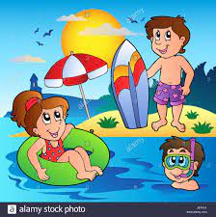 | 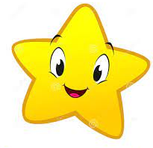  Under the Stars | Big and Small |   Build it Up |   Wonderful Water |   It’s Magic
 | - A House for Hermit Crab by Eric Carle  - Under the Sea by Anna Milbourne  - What the Ladybird heard on holiday by Julia Donaldson  - Room on the Broom by Julia Donaldson  - Shu Lin’s Grandpa by Matt Goodfellow and Yu Rong | - How to Catch a Star by Oliver Jeffers  - Whatever next! by Jill Murphy  - On the way home by Jill Murphy  - Handas Noisy Night by Eileen Brown  - Chubby Little Snowman  - Astro Girl by Ken Wilson-Max  - Little Glow by Katie Sahota and Harry Woodgate | - Billy goats Gruff  - The Gingerbread Man  - Cave Baby by Julia Donaldson  - The Very Busy Spider by Eric Carle  - The Hungry Caterpillar by Eric Carle (rhyme) | - The Three Little Pigs  - The Bear Hunt by Michael Rosen  - Paddington Bear (London) by Michael Bond  - The Train Ride by June Crebbin | - Polly Parrot picks a pirate by Peter Bently  - Pirates in the supermarket by Timothy Knapman  - Pirates love Underpants by Claire Freedman  - Umbrella by Elena Arevalo Melville | - Jaspers Beanstalk by Nick Butterworth  - The Magic Porridge Pot by Alan McDonald  - Rapunzel  - Fairy Tales  - We’re off to find a Fairy by Eloise White and Corey Reid  - Poems out Loud by Laurie Stansfield and various poets
FS  Second year  24-25 | You Are What You Eat  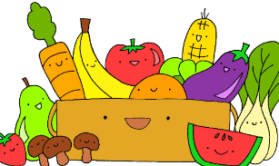 | Winter   | It’s Alive   | Exciting Environments  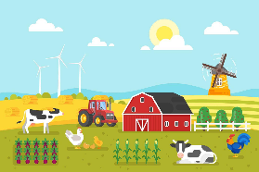 | Buckle Up   | Creepy Crawlies  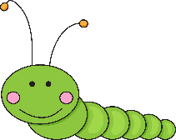
 | Supertato By Sue Hendra and Paul Linnet  Kitchen Disco By Clare Foges and Al Murray  The Tiger that cam for Tea By Judith Kerr  The hungry Caterpillar By Eric Carle | Room on the Broom Julia Donaldson  Stickman By Julia Donaldson  Winter – Seasons of the year  Winter poetry  A range of Christmas stories  Shante Keys and The New Years Pea’s | The Grufalo By Jiulia Donaldson  The Gruffulo’s Child By Jiulia Donaldson  Little Red Riding Hood traditional tale.  Animal Poems Compiled by Jennifer Curry  Book of Animal Poetry | Rosie’s Walk by Pat Hutchins  Where, Oh Where, is Rosie’s Chick by Pat Hutchins  What the Ladybird Heard by Julia Donaldson  What the Ladybird Heard on holiday by Julia Donaldson  Monkey Puzzle By Julia Donaldon | Whatever next By Jill Murphy  Aliens love underpants  Bob the man on the moon by Simon Bartrum  - Astro Girl by Ken Wilson-Max  The Train Ride  June Crebbin | The Very Hungry Spider by Eric Carle  Superworm By Julie Donaldson  Aaaaaghhhhh Spider By Lydia Monks  Creepy Crawly Non fiction Books
Year 1 | Our World   | Changes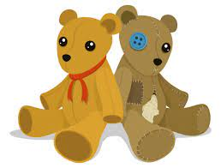 | The Mr Men 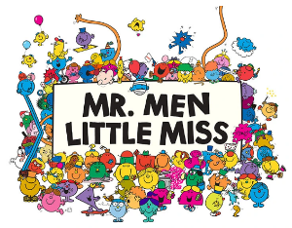 | Dinosaurs   | Growing   | Under the sea  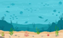
 | - Journey by Aaron Becker  - This is How we Do it by Matt Lamothe  - The Lion Inside by Rachel Bright  - Up and Down by Oliver Jeffers  - The Incredible Book Eating Boy by Oliver Jeffers  My Village: Rhymes from Around the World by Danielle Wright and Mique Moriuchi | - The Ugly Duckling  - Tiddler by Julia Donaldson  - And Tango Makes Three by Justin Richardson  - Toys Galore NF  - What are Toys made of? NF  - Toys in the past NF  - Scissors by Allen Ahlberg (Please Mrs Butler) | - Mr Men by Roger Hargreaves  - Lost and Found by Oliver Jeffers  - If all the World Were by Joseph Coehlo  - The More it Snows by AAMilne  - I do not mind you Winter wind by Jack Prelutsky | - How to Grow a Dinosaur by Caryl Hart  - Where the Wild Things Are by Maurice Sendak  - The Night Dragon by Naomi Howarth  The Girl and the Dinosaur by Holly Hughes  Stone Girl, Bone Girl by Laurence Anholt  Dachy’s Deaf by Jack Hughes  My Friend Earth by Patricia Maclachlan | - The Tiny Seed by Eric Carle (poem)  -Stuck by Oliver Jeffers  -The Big Book of Blooms by Yuval Zommer  -Seeds of Change by Jen Cullerton Johnson  -The Extraodindary Gardener by Sam Boughton  In the Garden by Roderick Hunt | - The Snail and the Whale by Julia Donaldson  - Rainbow Fish by Marcus Pfister  -Mr Seahorse by Eric Carle  -The Big Book of Blue by Yuval Zommer  -One day on our blue planet by Ella Bailey  -Homes through History by Sarah Gibb  -A Street Through Time by Steve Noon  -Dougals Deep Sea Diary by Simon Bartrom  -Amazing Animal Journeys by Chris Packham
Year 2 | 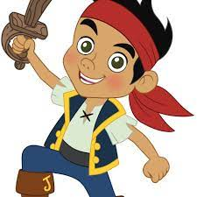  Pirates | 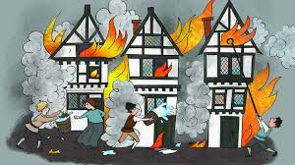  GFOL | 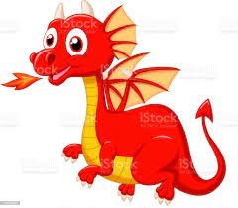  Dragons | Stories from the past |   Famous People | China
 | -The Pirate Cruncher / The pirate’s next door by Jonny Duddle  -Henry’s Freedom Box by Ellen Levine  The boy in the jam jar – Joyce Dunbar | - The Great Fire of London (Non-Fiction)  - Toby and The Great Fire of London by Margaret Nash | - The Egg by M.Th P. Robertson  - The Dragon Machine by Helen Ward  - The Owl and the Pussycat by Edward Lear  -The Quangle Wangle’s hate by Edward Lear | - The True story of the Three Little Pigs by John Scieszka  -Voices in the Park  Anthony Brown  -The Magic Faraway Tree – Jacqueline Wilson  -The Bog Baby by Jeanne Willis  Aesop’s Fables | - One Hundred Steps: The Story of Captain Tom  - Little Leaders: Bold Women in Black History by Vashti Harrison | The Water Dragon -  - The Ning Nang Nong by Spike Milligan  The Magic Porridge Pot by Rosie Dickens
Year 3 | 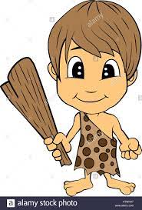  Stone Age | Oceans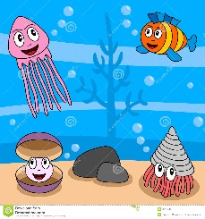 | Egyptians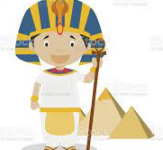 | Volcanoes  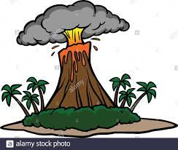 | 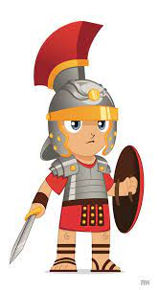  Romans | Romans
 | - Ugg by Raymond Brigg  - Little Wolf’s Book of Badness by Ian Whybrow  - The Iron Man by Ted Hughes  -The Witches by Roald Dahl | - Where the Forest Meets the Sea by Jeannie Baker  - Dear Greenpeace by Simon James  - Funky Chickens by Benjamin Zepheniah | Secrets of a Sun King by Emma Carroll  - How the Camel Got its Hump by Rudyard Kipling  - The World’s Greatest Space Cadet by James Carter | - The Dragon and the Nibblesome Knight by Elli Woolard (poem)  -The Lion, The Witch and the Wardrobe by C.S Lewis  The Angel of Nitshill Road by Anne Fine | - The Roman Beanfeast by Gillian Cross  -The Firework Maker’s Daughter by Phillip Pullman  - Beryl Goes Wild by Jane Simmons  - Cloud Busting by Malorie Blackman (poetry) | -Sulwe by Lupita Nyongo  - Laura’s Star by Klaus Baumgart  - Revolting Rhymes by Roald Dahl
Year 4 |   Henry VIII | 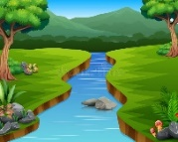  Rivers | 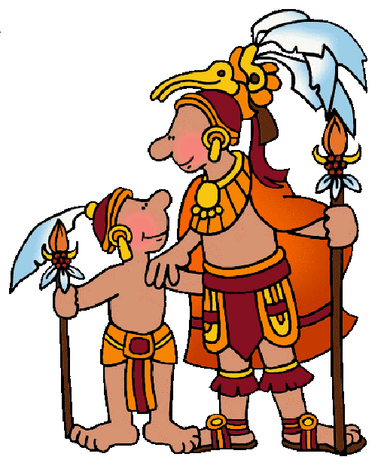  The Mayans |   Mexico | Anglo-Saxons and Scots  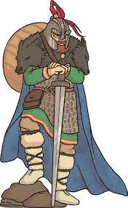 | The Amazon Rainforest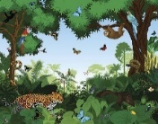
 | - The Thief the Fool and the big fat King by Terry Deary  - Diary of a Killer Cat – Anne Fine  - Noah Scape Can’t Stop Repeating Himself by Guy Bass  - After the Fall by Dan Santat  Krindlekrax – Phillip Ridley | Mr Stink – David Walliams  - The Night Bus Hero by Onjali Q Rauf  - The Night Before Christmas by Clemment C Moore  Please Mrs Butler – Allan Ahlberg | - Charlotte’s Web by EB White  - George by Alex Gino  The Secrets of St Lucia by Sara Grant | -Elise and the Second Hand Dog  - The Happy Prince and Other Tales by Oscar Wilde  The Last Bear by Hannah Gold | - Arthurian Legends  - The Proudest Blue by Ibtihaj Muhammad  The boy who made the world disappear - Ben Miller | - Where the Mountain Meets the Moon by Grace Lin  - Migrants by Issa Watanabe  - Hello H2O by John Agard
Year 5 | Mountains | 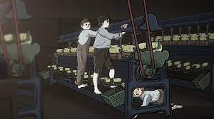  The Victorians and the Industrial Revolution | 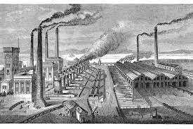  Industrial Revolution Armley |   Space / Science Fiction | 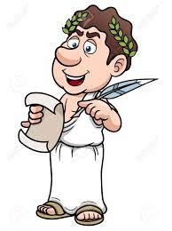  Ancient Greece |   Modern Greece
 | - Everest by Alexandra Stewart  -Escape the Room by Stephen Mangan  Escape Room by Christopher Edge  - The Sorceror’s Apprentice  - The Mad Professor’s Daughter by Allan Ahlberg (Heard it in the playground)  - The Tear Thief by Carol Ann Duffy | - Street Child by Berlie Doherty  - Charles Dickens extracts (Oliver Twist, A Christmas Carol, Great Expectations, David Copperfield)  - El Deafo by Cece Bell (biography)  -Fantastically Great Women Who changed the World by Kate Pankhurst  - The Charge of the Light Brigade by Alfred Tennyson | - Shakespeare (Macbeth, Midsummer Night’s Dream, The Tempest)  Alice in Wonderland by Lewis Carroll  - Lewis Carroll poetry (The Walrus and the Carpenter, The Jabberwocky) | - Cosmic by France Cottrell Boyce  - The Infinite lives of Maisie Day by Christopher Edge  - All The Things That Could Go Wrong by Stewart Foster | - Who Let The Gods Out by Maz Evans  - Greek Myths by Marcia Williams / Terry Deary  - Lost Magic by Brian Moses | - Silverfin (Young Bond) by Charlie Higson  - Percy Jackson by Rick Riordan  - The Boy at the Back of the class by Onjali Q Rauf
Year 6 |   WW2: The Blitz | North America  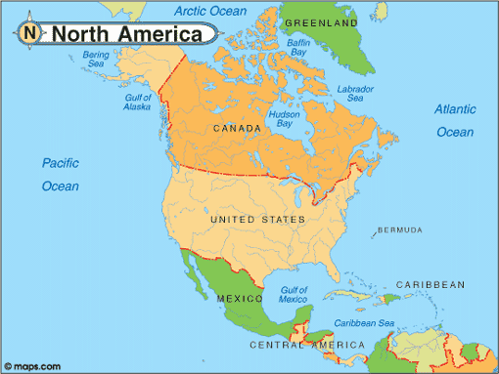 | 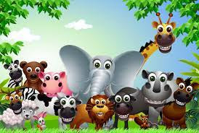  Living Things |   Vikings and Anglo-Saxons | 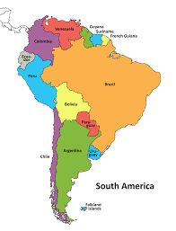  South America | 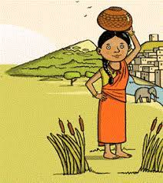  Indus Valley
 | - The Nowhere Emporium by Ross MacKenzie  - The Blitz by Robert Westall  - The War that Saved my Life by Kimberley Brubaker Bradley  - In Flanders Field by John McCrae  Letters from the Lighthouse – Emma Carroll | - Holes by Louis Sachar  - A series of Unfortunate Events by Lemony Snicket  - The Undefeated by Kwame Alexander  - The Arrival by Shaun Tan | - Beetle Boy by M.G Leonard  - Daffodils by William Wordsworth  - The Listeners by Walter de la Mare  - Overheard in a Tower Block by Joseph Coelho and Kate Milner (PSHE)  - Cicada by Shaun Tan | - Viking Myths  - The 1000 year old boy by Ross Welford  - Treasure Island by Robert Louis Stevenson  - Moonfleet by John Meade Faulkner  - New and Collected Poems for Childen (various)  The Red Tree by Shaun Tan | - Clockwork by Philip Pullman  - Oranges in No Mans Land by Elizabeth Laird  - The Lost Happy Endings by Carol Ann Duffy  - The Eagle by Alfred Lord Tennyson | - The Girl of Ink and Stars by Kiran Millwood Hargrave  - Asha and the Spirit Bird by Jasbinder Bilal  - If by Rudyard Kipling  - Can you See Me? by Libby Scott
Key:
Texts driving the unit
Narrative
Picture Books
Texts exploring and celebrating culture and diversity
Poetry

Note: Our Reading Spine does not identify specific non-fiction texts but these are expected to be part of your reading menu each half-term. These could be linked to topics, intended to develop wider knowledge and understanding, or sparked by children's interests.

