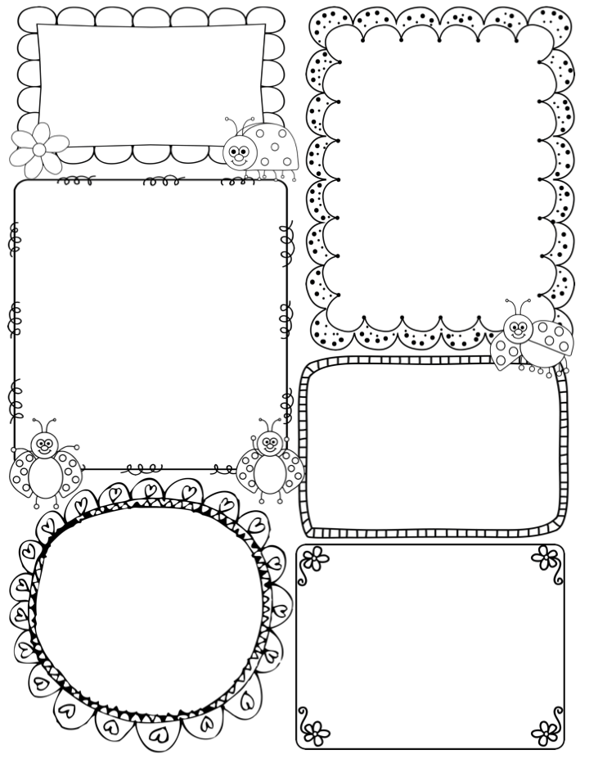
What we are learning

Our theme this half-term is ‘Under the Stars’. ​
In Literacy/ Phonics we are learning ​
differentiate between sounds in words
using out ‘Fred Fingers’.
​
We will be writing lists, labels and
writing cards.​ We will be focusing on letter formation and holding a pencil correctly.

In topic time we will learn about
the moon, planets, stars, bonfire night and Christmas.

In Math’s we will be focusing on numbers to 5, recognising the numerals, subitising, and adding 2 numbers together.

Welcome to Reception!
From
Miss Swift, Mrs Harrison,
Ms Binks, Mrs Fulton,
Mrs Patterson and Miss Eddison

General Information

Bookbags will still go out every Friday and are to be returned by the following Wednesday.
P.E is every Monday.
Please check Dojo regularly as we post pictures of what we are learning, and we also post any information or dates you need to be aware of. Such as Christmas party days and non-uniform days.

Stay and Play

Each half term, beginning next half term we will be having a ‘Stay and Play’ session. This will be when we invite parents into school to learn with their children in the classroom. This session will last about 45 mins. Out Autumn 2 Stay and Play will be held on Friday the 7th November at 2.15pm.

PE Day

We will have P.E sessions every week.
Please ensure you send your child to school with a labelled PE kit on a Monday. They also have a peg each which they can leave their PE kit on.
PE Kit:
A plain white polo top or T-Shirt
Black or Navy shorts.
Please encourage your child to be as independent as possible getting dressed at home.

Christmas Performances

We will be doing a foundation stage and key stage one Christmas performance keep checking Dojo for details. All the children will be taking part in singing all the songs and some might have small parts on stage. We hope you can come and make it to watch.

Uniforms
Just a reminder that school uniform is a white or navy collared T-shirt/shirt, a navy jumper and grey, black or navy dress, skirt or trousers.
We also advise suitable footwear that children are able to put on independently. If they are unable to do their laces, please don’t sent them with laces to do.
Please REMEMBER to label
everything your child
brings to school!
HT1 TOPIC:
You Are What You Eat!
In the first half term our topic will be ‘You Are What You Eat’’ We will be exploring what the children already know, and also what they would like to find out about this topic. We will be reading an exciting story book, ‘Supertato’ and will explore in the provision areas also. We encourage the children’s ideas and are very excited to see where the children would like to take their learning.
Shoes and Pumps
Please send your children in suitable shoes for school which are again clearly labelled. We will also be asking that the children bring in pumps as indoor shoes to change into in the first few weeks. These will then stay in school and the children can practice being independent and change their shoes themselves.

Maths and Literacy Learning
For the first half term in Maths, we will be following the ‘Maths Mastery approach’ and the Steps to Success to count objects reliably, as well as really focusing in on numbers 0, 1 and 2. We look at these numbers in depth which helps secure children’s confidence in using the numbers.
In Phonics we will be using the ‘Read Write Inc scheme’, where again the children will access learning, specific to their abilities, straight away, helping them to recognise and read graphemes, (letters) and the phonemes (sounds) they make. We will have a huge focus on name writing. The children will be expected to write their name starting with a capital letter and forming all the letters correctly.
Please practice with your child at home.
First week of School
We have absolutely loved welcoming the new Reception children this week, and we have had so much fun learning the routines; finding different areas to play in in our classroom; and making new friends!
Just a quick reminder that all children need to be in school full time from the first day,
Monday 5th September.
From this week the children can expect daily phonics, Maths and Literacy sessions and the children will be learning through play in the areas of provision, which have been carefully set up to enable the children’s development. Each week they will also take part in P.E, Knowledge and Understanding of the World, Music and SEAL session.

Reception HT1
From
Miss Swift, Mrs Cooper, Mrs Knights,
Ms Binks, Mrs Massey, Mrs Sykes,
Miss Olga, Mrs Sunderland,
Mrs Waterhouse and Miss Smith.

