
Whingate Primary School – Geography
North America |   YEAR 6

North America Fact 1: | North America Fact 2: | North America Fact 3: | North America Quiz Questions:
It is home to the largest island on Earth: Greenland. | The largest city in North America is Mexico City. It is 573 square miles and has a population of 2.2 million. | All countries in the entire continent of North America touch the ocean. | 1 - How many states are there in the USA?  2 - Who is the current president?

Images: | Vocabulary: | What we will learn in this unit (skills):
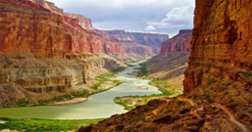  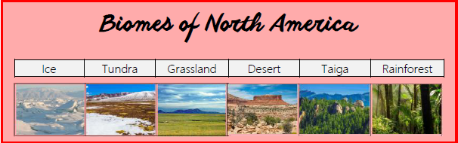 | Biomes: Area of land where the climate and habitat are similar.  Characteristics: A feature in geography: this can be naturally occurring or man-made.  Continent: One of the World’s main expanses of land which may consist of many countries.  Country: A region - A continent is divided into these.  Desert: An area where there is little or no water leaving it very dry.  Equator: A line which divides the Northern and Southern hemispheres.  Lines of Latitude: Lines which divides the earth into zones (Equator, Tropic of Cancer, Tropic of Capricorn, Arctic Circle, Antarctic Circle).  Northern Hemisphere: The Northern part of our Earth.  Settlement: Somewhere where humans live.  Southern Hemisphere: The Southern part of our Earth.  State: A part of a country. For example, California is a state in the USA.  Taiga: A cold coniferous forest usually in the North.  Tropics: The area around the Equator which has a tropical environment.  Tundra: Frozen land. | - Use world maps, atlases and globes to locate physical features (climate zones)  - Read and compare map scales  - Use latitude/longitude on globes and atlases  - Use 8-point compass directions to locate places and to give directions and instructions.  - Use web searches, postcodes and zoom to find places on digital maps.
Sticky Knowledge: |  | What we will learn in this unit (knowledge):
-Know there are 23 countries that make up North America.  -Know some of the biomes of North America.  -Know some environmental differences within different biomes.  -Know why people live in certain areas of North America.  -Use an 8-point compass to locate places within North America. |  | - Name and locate countries of North America concentrating on environmental regions, key physical and human characteristics, countries and major cities.  - Compare region in UK to a region in a North America (human and physical geography).  - Identify all lines of latitude and longitude and identify key features of climate zones.  - Study key aspects of human geography including types of settlement and land use.
Assessment - Fill in the gaps:
Name three countries in North America:
______________ , _______________ , _________________

Name three states in the USA:
______________ , _______________ , _________________

