**Design Technology**

**Year 6 – Summer Term**

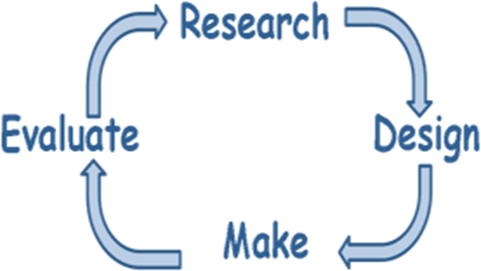

Cooking

Unit skills overview:

* How to use utensils to prepare, mix, prove and create.
* **Research** and come up with ideas to make a bread product.
* Design a bread sculpture or loaf.
* Make a bread sculpture or loaf.
* Evaluate our designs, making process and taste.
* Re-make our bread sculptures using improvements discussed in the evaluation.
* Present our bread products to be judged.
* Reflect upon the feedback given.

Design

* Come up with a range of ideas thinking about the purpose.
* Talk about my ideas saying who will want this product .
* Make simple drawings and label parts.

Make

* Use utensils to make my product.
* Use utensils safely.
* Use finishing touches to make my product appealing.
* Follow a simple recipe.

Evaluate

* Using my senses to evaluate.
* Evaluate against my design criteria

Re-make

* Based upon the evaluations made of the first make process, make adjustments to the recipe and design to make it tastier, more visually appealing, and ultimately more successful.

Presentation and feedback

* Use presentational devices to share the making process.
* Provide materials to gather feedback from the audience (DT Showcase Event).

