
Whingate Primary School – History
WWII – The Blitz |   YEAR 6

Blitz Fact 1: | Blitz Fact 2: | Blitz Fact 3: | WWII Quiz Question:
The word Blitz comes from the German word ‘Blitzkrieg’ meaning lightning war. | During the Blitz, almost 1 million bombs were dropped on London. | About 40,000 civilians died during the Blitz, over half in London. | Who was Winston Churchill?

Images: | Vocabulary: | What we will learn in this unit (skills):
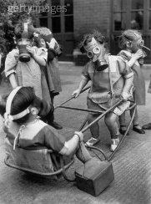  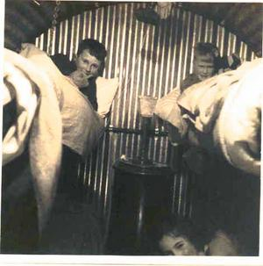  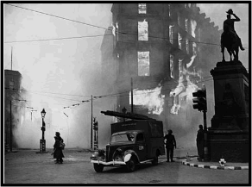  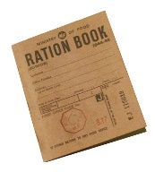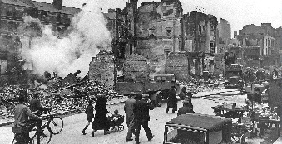 | air raid – An attack by military aircraft in which bombs are dropped.  Allies – The Allies were the armed forces that fought against Germany in WWII.  Axis – The Axis were the armed forces that fought against the UK in WWII.  Blitz – The heavy bombing of British cities by Germain aircraft in 1940 and 1941.  defend – To take action in order to protect something.  evacuate – To send someone to a place of safety.  invasion – To try and take over a place by force.  Luftwaffe – The German Air Force.  Nazi – A member of the far-right political party in Germany.  rationing – The system of limiting the amount of food, water, fuel and other substances when supplies are limited. | Chronology – Place events in chronological order on a timeline.  Sources – Use primary and secondary sources to find out about the past.  Making Connections – Compare and contrast aspects of life in different time periods.  Enquiry – Explain how events from the past impact upon the modern world.  Communicating – Communicate our knowledge in different forms.  Questioning – Ask and answer questions about the past.
Sticky Knowledge: |  | What we will learn in this unit (knowledge):
-Know the Blitz was a significant event in British History.  -Know the key events of World War 2.  -Know which countries were involved in World War 2.  -Know the impact of the Blitz on daily life in Britain.  -Know that food was rationed and why.  -Know the impact of World War 2 on Armley. |  | We will:  - order key events in chronological order.  - identify where the Blitz happened in relation to other events in WWII.  - use resources to research aspects of life during the Blitz.  - explain what life may have been like during The Blitz.  - explain the evacuation process.  - explain what happened to end the Blitz as well as ending WWII.
Assessment - Fill in the gaps:
Name three countries for each group:
Axis - ___________ , _____________ , _______________
Allies - ______________ , _______________ , _______________

WWII – 19__ __ to 19 __ __

